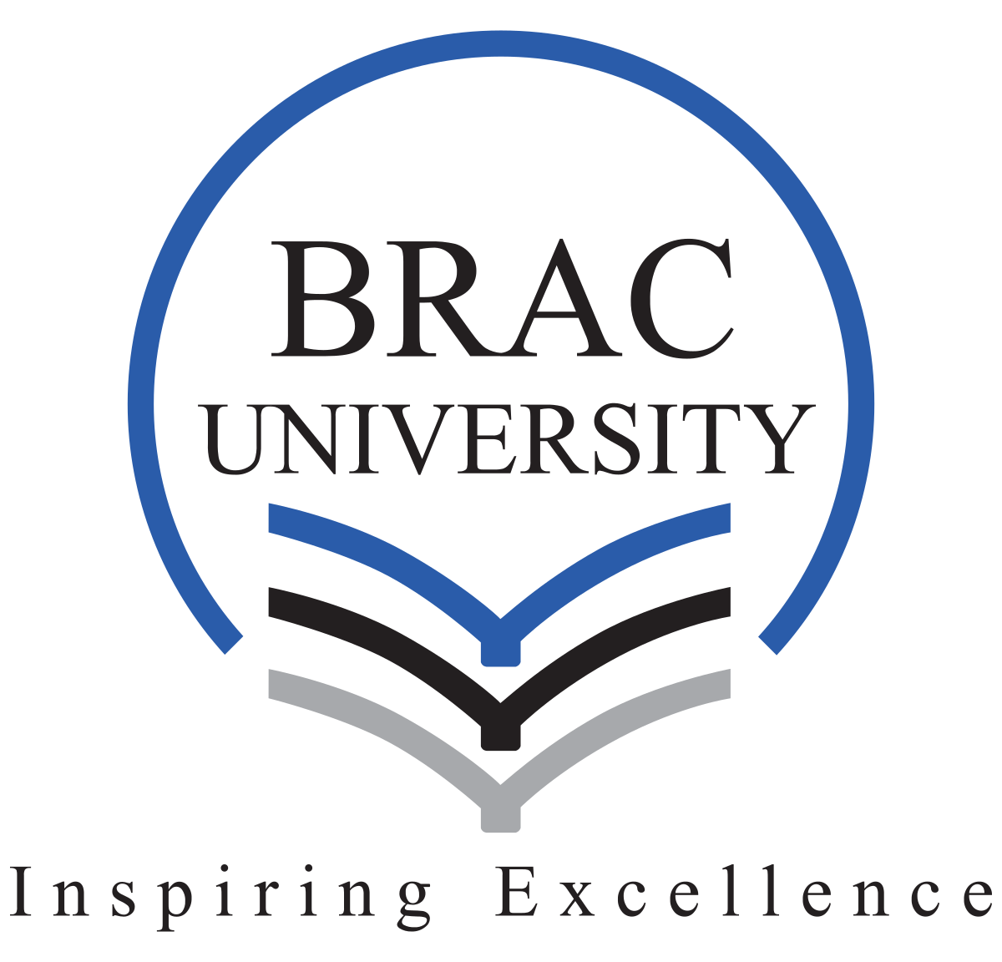

Annual Report Analysis
Five DSE-Listed Companies Across Different Industries

Submitted by
Md Rifat Rahman
Student ID: 1000054675

BUS526 Section: 2
Submission Date: 11th March 2026

Table of Contents
Introduction
1. Grameenphone Ltd
2. Square Pharmaceuticals Ltd
3. BRAC Bank Limited
4. LafargeHolcim Bangladesh Ltd
5. BEXIMCO Ltd
6. Comparative Analysis and Conclusion

Introduction
The objective of this assignment is to select and summarize the annual reports of five companies listed on the Dhaka Stock Exchange (DSE), each representing a distinct industry sector.
The five companies selected are (1) Grameenphone Ltd. (Telecommunications), (2) Square Pharmaceuticals Ltd. (Pharmaceuticals and Healthcare), (3) BRAC Bank Limited (Banking and Financial Services), (4) LafargeHolcim Bangladesh Ltd. (Building Materials-Cement), and (5) BEXIMCO Ltd. (Diversified Conglomerate). This sectoral diversity enables a comparative understanding of financial performance, strategic priorities, and risk profiles across different segments of the Bangladeshi economy.

1. Grameenphone Ltd (GP)
GP | Telecommunications | DSE | FY 2023
1.1 Company Overview
Grameenphone Ltd is Bangladesh's largest mobile telecommunications operator and a subsidiary of Telenor ASA, Norway. Founded in 1996 and listed on the Dhaka Stock Exchange, GP serves over 85 million subscribers with approximately 45% national market share. The company provides voice, data, and digital services across all 64 districts of Bangladesh.

1.2 Key Financial Indicators
The following table summarises key financial metrics from the company's annual report:
Metric | Value (FY 2023)
Revenue | BDT ~155.4 Billion
Net Profit After Tax | BDT ~33.2 Billion
EBITDA Margin | ~54%
Earnings Per Share (EPS) | BDT 24.55
Dividend Per Share | BDT 16.50
Total Assets | BDT 220+ Billion
Subscriber Base | ~85 Million+

1.3 Operational Highlights
- Continued 4G network expansion across all 64 districts of Bangladesh.
- Data and digital services now account for approximately 43% of total revenue.
- Investment in MFS partnerships and fintech ecosystem development.
- Highest EBITDA margin in the Bangladesh telecommunications sector.
- Spectrum acquisition and 5G readiness planning initiated.
- Consistent dividend payout maintained for shareholders.
- CSR activities in health, education, and digital literacy.

1.4 Strategic Direction
GP's strategy focuses on transitioning from a traditional telecom operator to a digital services provider. Key priorities include deepening rural 4G coverage, preparing 5G infrastructure, and building a digital value-added services ecosystem. These efforts align with Bangladesh's Smart Bangladesh Vision 2041.

1.5 Key Risks and Challenges
Key risks include regulatory pressure on tariff structures, intense competition from Robi and Banglalink, spectrum renewal costs, foreign exchange volatility affecting dividend repatriation to Telenor, and evolving cybersecurity threats.

2. Square Pharmaceuticals Ltd
SQURPHARMA | Pharmaceuticals & Healthcare | DSE | FY 2022–23
1.1 Company Overview
Square Pharmaceuticals Ltd is the largest pharmaceutical company in Bangladesh with approximately 18–20% domestic market share. Founded in 1958, the company manufactures tablets, capsules, injectables, liquid preparations, and veterinary medicines. Its products are exported to over 40 countries including regulated markets in the United States and Europe.

1.2 Key Financial Indicators
The following table summarises key financial metrics from the company's annual report:
Metric | Value (FY 2022–23)
Revenue | BDT ~57+ Billion
Net Profit After Tax | BDT ~8.5+ Billion
Earnings Per Share (EPS) | BDT 15.50+
Dividend Per Share | BDT 8.00+ (Cash & Stock)
Return on Equity (ROE) | ~22%
Total Assets | BDT ~65+ Billion
Export Revenue Share | ~10% of Total Revenue

1.3 Operational Highlights
- Consistent domestic market leadership with uninterrupted revenue and profit growth.
- Export portfolio expanded to 40+ countries including WHO pre-qualified regulated markets.
- Major capital expenditure on WHO-GMP compliant manufacturing facilities.
- New biosimilars and novel molecule formulations launched domestically and for export.
- Robust R&D pipeline with rising investment in new drug development.
- Unbroken dividend payout history maintaining status as a preferred income stock.
- Backward integration into API manufacturing underway to reduce import dependency.

1.4 Strategic Direction
The company's strategic agenda is to expand into high-compliance regulated export markets (USA, UK, EU, Australia) while deepening domestic leadership in high-growth therapeutic segments such as oncology, cardiovascular, and diabetes. Backward integration into Active Pharmaceutical Ingredient (API) manufacturing is a key margin-improvement priority.

1.5 Key Risks and Challenges
Significant risks include the compliance burden of regulated export markets, raw material price volatility tied to the USD, intensifying generic competition domestically, potential pharmaceutical pricing policy interventions, and the impact of Taka depreciation on import costs.

3. BRAC Bank Limited
BRACBANK | Banking & Financial Services | DSE | FY 2023
1.1 Company Overview
BRAC Bank Limited is one of Bangladesh's leading private commercial banks, established in 2001 as a subsidiary of BRAC-the world's largest non-governmental development organization. The bank has pioneered SME banking in Bangladesh and operates bKash, the country's largest Mobile Financial Service (MFS) platform with over 70 million registered users.

1.2 Key Financial Indicators
The following table summarises key financial metrics from the company's annual report:
Metric | Value (FY 2023)
Total Operating Income | BDT ~25+ Billion
Net Interest Income (NII) | BDT ~18+ Billion
Net Profit After Tax | BDT ~6+ Billion
Earnings Per Share (EPS) | BDT ~5.50+
NPL Ratio | ~3.5%
Capital Adequacy Ratio (CAR) | ~14%+
Total Deposits | BDT ~380+ Billion

1.3 Operational Highlights
- SME lending constitutes over 40% of the total loan portfolio.
- bKash subsidiary surpassed 70 million registered users.
- Significant growth in internet and mobile banking active users.
- Agent banking network expanded into underserved rural districts.
- Capital Adequacy Ratio maintained above Bangladesh Bank's statutory minimum.
- Green banking and climate-risk lending frameworks formally adopted.
- Internationally recognised for SME banking excellence and financial inclusion.

1.4 Strategic Direction
BRAC Bank's strategy is built on three pillars: deepening SME penetration in under-banked areas, accelerating retail banking through digital channels, and leveraging bKash to converge banking and mobile financial services. ESG integration across lending portfolios is also a growing strategic priority.

1.5 Key Risks and Challenges
Notable risks include rising NPLs in the SME portfolio due to inflationary pressure on small businesses, interest rate risk from Bangladesh Bank's policy tightening, foreign currency exposure in trade finance, cybersecurity risks from a large digital banking operation, and increasing regulatory compliance costs.

4. LafargeHolcim Bangladesh Ltd
LAFARGEHLCM | Building Materials-Cement | DSE | FY 2023
1.1 Company Overview
LafargeHolcim Bangladesh Ltd is the local subsidiary of Holcim Group, Switzerland, and the only fully integrated cement manufacturer in Bangladesh. Its limestone quarry in Chhatak, Sunamganj, provides a structural cost advantage over competitors relying on imported clinker. The company produces Portland Cement, Clinker, and Ready-Mix Concrete (RMC), primarily for large infrastructure projects.

1.2 Key Financial Indicators
The following table summarises key financial metrics from the company's annual report:
Metric | Value (FY 2023)
Revenue | BDT ~28+ Billion
Net Profit After Tax | BDT ~1.5+ Billion
Earnings Per Share (EPS) | BDT ~2.50+
Gross Profit Margin | ~20–22%
Installed Capacity | ~3 Million MT per annum
Clinker Production | ~2.5 Million MT
Domestic Market Share | ~8–10%

1.3 Operational Highlights
- Cost advantage maintained through integrated quarry-to-cement production.
- Revenue supported by strong government infrastructure spending.
- Ready-Mix Concrete business expanded in Dhaka and Chittagong.
- Holcim Group's global sustainability practices adopted locally.
- Energy efficiency programmes reduced cost per tonne of cement.
- Eco-product portfolio developed for the green building segment.
- Quarry expansion at Chhatak sanctioned to increase limestone capacity.

1.4 Strategic Direction
The company's strategy focuses on capitalising on its integrated production advantage by expanding quarry capacity. RMC segment growth targeting large-scale infrastructure projects is a secondary priority. Sustainability is a core pillar: reducing carbon emissions per tonne, increasing alternative fuels use, and developing low-carbon cement products aligned with Holcim Group's global climate commitments.

1.5 Key Risks and Challenges
Key risks include high natural gas and energy costs, price competition from approximately 40 domestic cement manufacturers, cyclical demand linked to government capital expenditure, flooding and geological risks at the Chhatak quarry, and currency depreciation affecting imported inputs.

5. BEXIMCO Ltd
BEXIMCO | Conglomerate-Textile, Energy, Real Estate, Media | DSE | FY 2022–23
1.1 Company Overview
BEXIMCO Ltd is the flagship entity of the BEXIMCO Group, one of Bangladesh's largest and most diversified conglomerates. Business interests span textiles and ready-made garments, energy and power generation, real estate, and media. The Group employs over 35,000 people and its textile arm is a major exporter supplying global brands including Zara, H&M, and Marks & Spencer.

1.2 Key Financial Indicators
The following table summarises key financial metrics from the company's annual report:
Metric | Value (FY 2022–23)
Consolidated Revenue | BDT ~38+ Billion
Net Profit After Tax | BDT ~3+ Billion
Earnings Per Share (EPS) | BDT ~3.50+
Total Assets (Consolidated) | BDT ~150+ Billion
Power Generation Capacity | 750+ MW (Group level)
Employee Headcount | 35,000+ (Group)
Export Markets | 40+ countries

1.3 Operational Highlights
- Garment export revenues recovered strongly following post-COVID-19 global demand rebound.
- Long-term supply agreements secured with major global fashion brands.
- BEXIMCO Power contributed stable energy revenues through IPP arrangements.
- Real estate segment benefited from sustained housing demand in Dhaka.
- Investment in modern spinning and weaving machinery to expand production capacity.
- International labour and environmental compliance standards maintained.
- Conglomerate diversification provided earnings resilience across sector-specific downturns.

1.4 Strategic Direction
BEXIMCO's strategy is to move up the garment value chain from basic readymade garments toward higher-margin technical textiles and sustainable fashion products. In energy, the company aims to expand renewable generation capacity to power factories sustainably and meet international buyers' ESG requirements. Cross-subsidiary synergies are expected to support real estate development projects.

1.5 Key Risks and Challenges
Key risks include global apparel demand volatility, foreign exchange risk on export receivables, rising energy and raw material costs, geopolitical trade disruptions, labour cost inflation in Bangladesh, governance and transparency concerns associated with a politically connected conglomerate structure, and elevated debt levels across the Group.

6. Comparative Analysis and Conclusion
6.1 Cross-Company Comparison
The table below provides a comparative overview of the five companies across key dimensions:
Dimension | Grameenphone | Square Pharma | BRAC Bank | LafargeHolcim | BEXIMCO
Industry | Telecom | Pharma | Banking | Cement | Conglomerate
Revenue Scale | Highest | Large | Large | Medium | Large
Profitability | Very High | High | Moderate–High | Moderate | Moderate
Dividend Record | Consistent | Consistent | Growing | Variable | Variable
Growth Driver | Data & Digital | Export & R&D | SME & bKash | Infrastructure | Textile Export
Primary Risk | Regulation | Raw Materials | NPL Rise | Energy Costs | High Debt

6.2 Observations
- Grameenphone leads in profitability, supported by its scale and operating leverage, though it remains vulnerable to regulatory and competitive pressure.
- Square Pharmaceuticals demonstrates diversified, consistent growth, with export expansion into regulated markets providing structural resilience.
- BRAC Bank holds a unique position at the intersection of banking and digital financial services through bKash, offering high long-term growth potential.
- LafargeHolcim's integrated production model confers a cost advantage; however, a fragmented market and high energy costs constrain profit margins.
- BEXIMCO's conglomerate diversification provides revenue stability, but elevated leverage and governance complexity represent material investor risks.

6.3 Conclusion
The five companies analyzed represent a meaningful cross-section of Bangladesh's most commercially significant industries. Each exhibits a distinct financial profile, strategic logic, and risk landscape reflective of its sector. Grameenphone and Square Pharmaceuticals stand apart for their profitability and consistent shareholder returns. BRAC Bank illustrates how digital transformation reshapes financial institutions. LafargeHolcim demonstrates the enduring value of vertical integration in manufacturing. BEXIMCO underlines both the diversification benefits and governance complexities of large emerging-market conglomerates.
From a managerial finance perspective, this exercise reinforces the importance of capital structure decisions, dividend policy, and strategic investment allocation in determining long-run firm value. All five firms operate within an evolving regulatory and macroeconomic environment shaped by Bangladesh Bank monetary policy, government capital expenditure cycles, global trade patterns, and the national Smart Bangladesh Vision 2041—contextual forces that are as important to understand as the financial statements themselves.

